**2 PERFECT DAYS IN VIBRANT LJUBLJANA**

Start you adventure in Ljubljana, an attractive and friendly city with a green soul. It has a relaxed vibe and is a pleasant place to be with affordable attractions, accommodation and food. If you’re looking for something increasingly popular among travellers, you are at the right place. Its distinctive and attractive cityscape makes Ljubljana among the most beautiful cities in Europe

It all begins with your arrival…

**DAY 1**

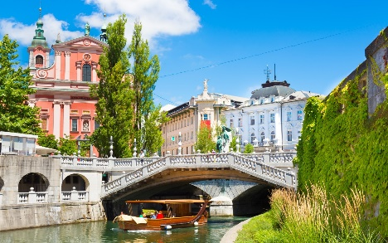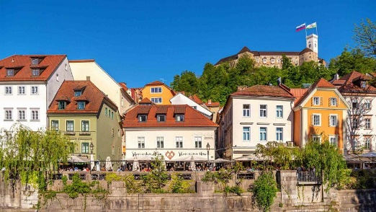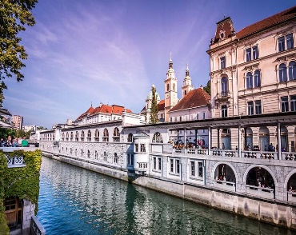

   

*But first, let’s take a look at the history of Ljubljana, to give you some historical background for your first day visit to Ljubljana.*

Legend has it that Ljubljana was founded by Jason, the hero of Greek mythology who stole the golden fleece from King Aeëtes and then fled aboard the Argo with his comrades, known as the Argonauts, across the Black Sea and up the Danube and the Sava until they reached the Ljubljanica. There they dismantled their ship in order to carry it overland to the Adriatic coast, where they rebuilt it and set sail back to Greece. Before Jason and the Argonauts reached the source of the Ljubljanica, they came across a great lake and, next to it, a marsh, where Jason encountered a terrible monster, which he fought and killed. That monster was the Ljubljana dragon, which today lives atop the castle tower on the Ljubljana coat of arms.

**DAY 1**

**EXPLORE DOWNTOWN**

Step outside and take a wander around **Ljubljana Central Market**. Ljubljana's Central Market is more than just a place to shop. Traditionally, it has also been a place for the locals to meet and enjoy themselves together. Explore indoor and outdoor market area, which is open every day exept Sundays.

One of the best things about visiting Ljubljana is getting to try Slovenian cuisine. Have a brunch at **Moji Štruklji.** Located in Plečnik’s arcade at Ljubljana’s central market, this “štrukljarnica” serves up a daily range of more than 20 different types of štruklji – boiled strudel – with creamy or classic fillings and toppings. Treat yourself to traditional varieties such as cottage cheese, tarragon, apple or a buckwheat version with walnuts.

**A HINT:** You can join Yummy market walk, a guided tour through Ljubljana Central market, which is availabe from Tuesday to Friday at 9:00 o'clock and make it easier for you.

Join regular guided tour of Ljubljana. This 2 hour walking tour of historical city center starts at 11am and finishes with a funicular ride up to the **Ljubljana castle**. At Ljubljana castle you can get the best view of the city and it is known as favourite photo-spot. Guide focus on explaining major attractions and local life in Ljubljana, so you get a unique and in-depth perspective.

After the tour have a lunch at one of the restaurants offering [**Taste Ljubljana dishes**](https://www.visitljubljana.com/en/visitors/things-to-do/food-and-drink/article/taste-ljubljana/) **(link ali QR koda).**

**The river Ljubljanica**, with its interesting bridges and picturesque old city centre embankments, is one of Ljubljana's most notable landmarks which you can not miss.

The heart of Ljubljana's social life are the Ljubljanica river embankments, densely scattered with lively **cafés** offering outdoor seating. A good way to see the old city centre and its famous bridges, picturesque buildings and vibrant embankments from a completely different angle is to join a **[tourist boat cruise](http://www.visitljubljana.com/en/visitors/tours-and-trips/?category=19" \t "_blank)** along the river.

However, the Ljubljanica with its bridges is much more than just photogenic. It offers unique experiences which you simply must try. In the summer you can join a**[sup](http://www.visitljubljana.com/en/visitors/tours-and-trips/stand-up-paddling-on-the-ljubljanica/" \t "_blank)** or a**[kayak tour](http://www.visitljubljana.com/en/visitors/tours-and-trips/rowing-down-a-calm-moorland-river/" \t "_blank)** and paddle through the city centre.

Looking for some fun and entertainment? Ljubljana is a place where you can be sure to find something to enjoy. Experience Ljubljana’s nightlife - **[Check out all the events in Ljubljana](http://www.visitljubljana.com/en/events/" \t "_blank)** for the time of your stay.

**DAY 2**

**HISTORY, PARKS, CULTURE AND MORE**

Treat yourself to a cultural break in a creative city with a buzzing lifestyle.

Start you day with a great coffe at **Cacao**,  located by the river Ljubljanica and offering a beautiful view of the Central Market's colonnade, designed by the architect **Jože Plečnik**, offers home-made ice creams, other sweet delights, sandwiches and natural juices.

Rent a bike at **Tourist information center** and explore cultural Ljubljana. Star with our famous architect Jože Plečnik. The multitude of his creations in the city, referred to as a whole as "Plečnik's Ljubljana", is considered to be one of the 20th century's most important total works of art.

Take a broshure in Tourist information center and drive down to his house. The Plečnik House was, of course, where the **famous architect Jože Plečnik** lived and worked. After visit indulge yourself with Plečnik’s tea and honey gingerbread biscuits are available for purchase at the **[café of the National and University Library](https://www.nuk.uni-lj.si/eng/)**. The tea is also sold by select specialist shops around Ljubljana.

**HINT:** Have you ever wondered what would happen if Plečnik had fulfilled all his dreams? Behold his visions and discover his hidden ambitious plans. Take a walk from the invisible bridge, the mighty magistrate, and the legendary, never-built square, and marvel at what it would be like if he had made it all happen.

The NEXTO Ljubljana app is available free of charge for [**Android**](https://play.google.com/store/apps/details?id=app.loco.nextoljubljana&hl=en&gl=US) and [**iOS**](https://apps.apple.com/us/app/nexto-ljubljana/id1572537260).

Near by do not miss seeing the world’s oldest wooden wheel with an axle (5,200 years old) **at the City Museum.**

If we are speaking about the oldest things in the world you can find another one in Ljubljana- the oldest musical instrument in the world – a 60,000-year-old Neanderthal flute **at the National Museum.**

It is time for a lunch. Ljubljana is a world in miniature and offers culinary adventurers a rich and diverse range of foods to suit all tastes and all pockets. Ljubljana’s food scene is like the city itself: ancient but youthful, refined but boisterous, local but cosmopolitan.[**Taste Ljubljana dishes**](https://www.visitljubljana.com/en/visitors/things-to-do/food-and-drink/article/taste-ljubljana/) **(link ali QR koda).**

The rich collection of works by Slovene impressionists is the biggest attraction **at the National Gallery**, while the Museum of Modern Art contains works by leading artists of the twentieth century.

Just behind gallery you can see a green park called Tivoli, where you can have a break and a great coffe **at Caffe Bienale.**

While exploring the city’s rich history of artistic heritage, you should also visit the museum complex on **Metelkova Ulica and Metelkova city as well.** An alternative culture centre that developed from a squat in a former army barracks and became one of the best known attractions of Ljubljana, brings together a variety of different artistic practices and events.

Finnish you day with tasting of some local beers or wines.

If you are you a beer lover who’d like to become familiar with the beer brewing tradition in Ljubljana? Enjoy tasting beers from different brewers from Ljubljana and its vicinity. Join a guided tour **Ljubljana beer experience.**

If you prefer wine, taste seven premium wines from different wine regions of Slovenia in the company of a sommelier and in a 300-year old wine cellar and join **interactive wine experience**.

**TO MAKE IT EVEN EASIER:** To make your stay easier, purchase a [**48h tourist card**](https://www.visitljubljana.com/en/visitors/ljubljana-card/) to explore Ljubljana.

We also can give you plenty of options for nearby day trips, if you have more than two day in Ljubljana. You can use Ljubljana as a base for tripping around Slovenia. Stop by in our Tourist information center and make a resevration for you day trip.

**DO NOT FORGET:** Take a peace of Ljubljana with you: Torusit information office offers several attractive ranges of souvenirs that are also highly practical and will leave you with a lasting memory of Ljubljana.